## Appendix A – Screenshots for Study *Screen 1*

## 

## *Screen 2 (in-group condition)*

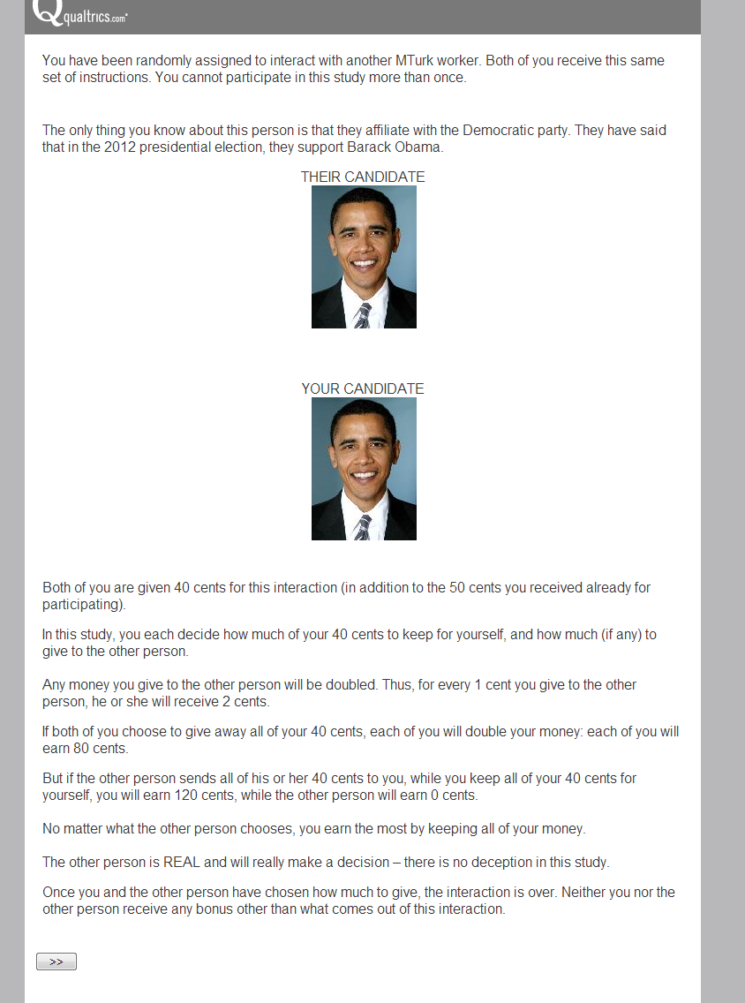

*Screen 3 – Time pressure condition*

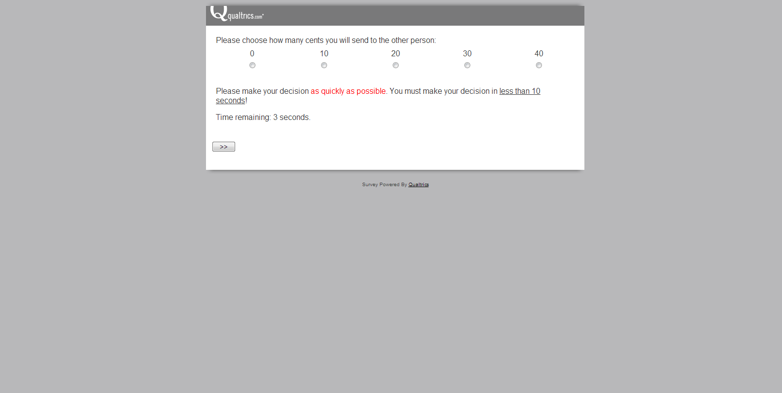

*Screen 3 – Time delay condition*

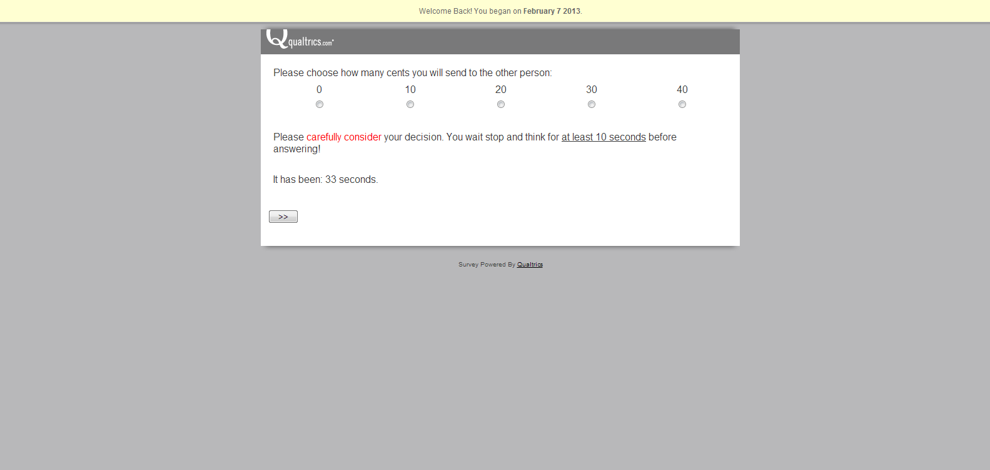

*Screen 4*

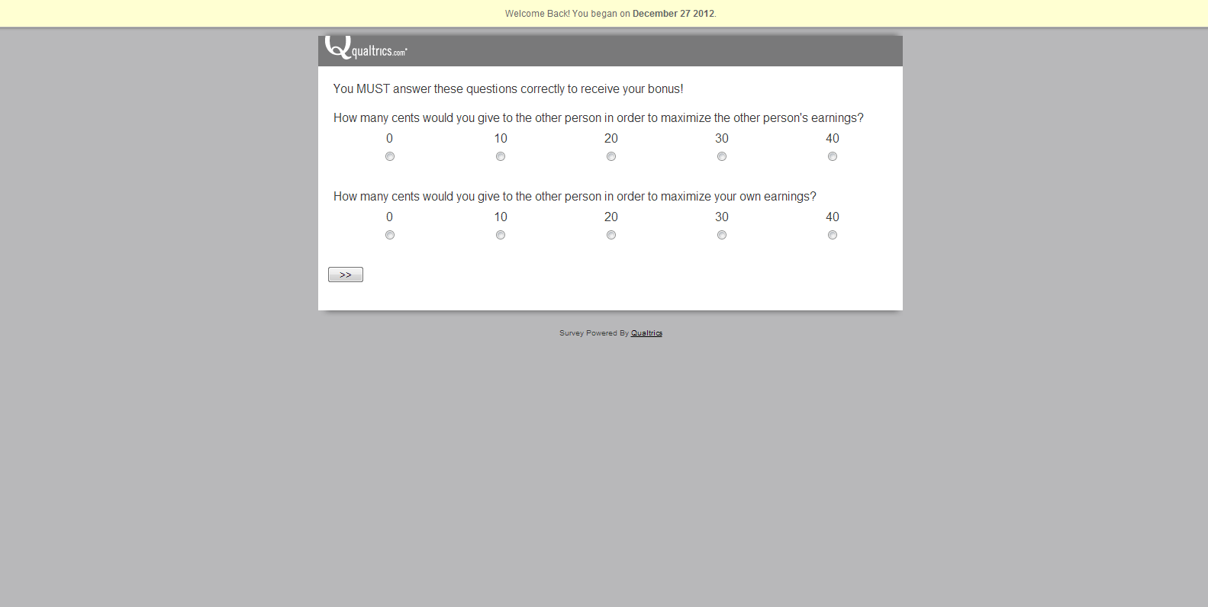

## Appendix B: Screenshots for Study 2

## *Screen 1 - Collaboration condition*

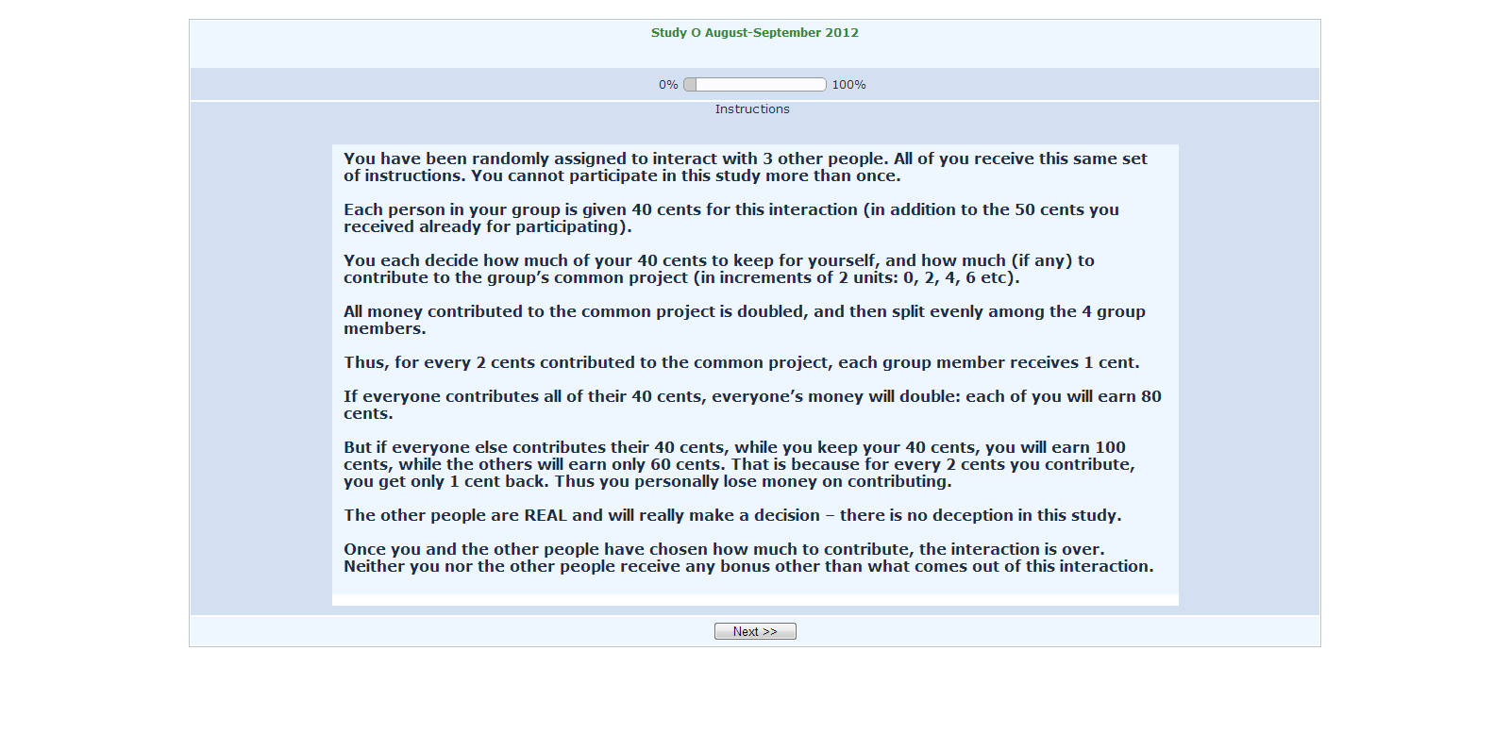

*Screen 1 – Competition condition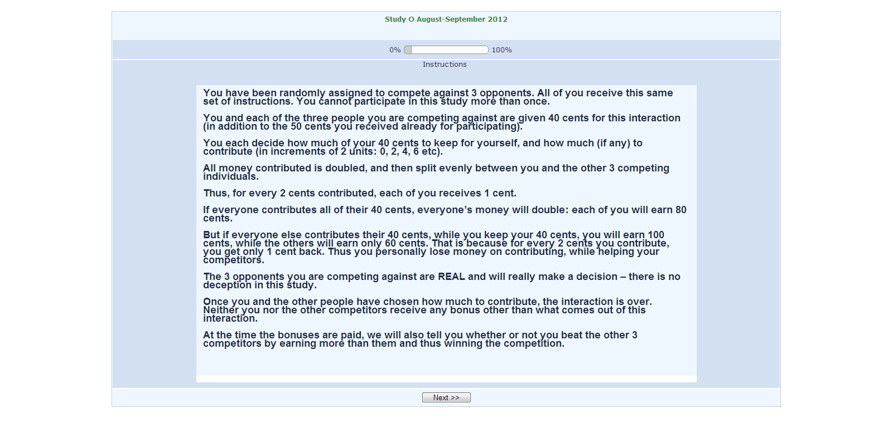*

*Screen 2 – Time pressure condition*

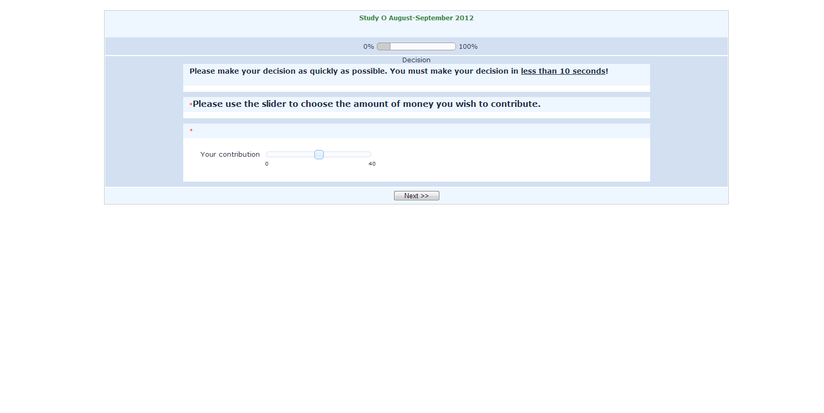

*Screen 2 – Time delay condition*

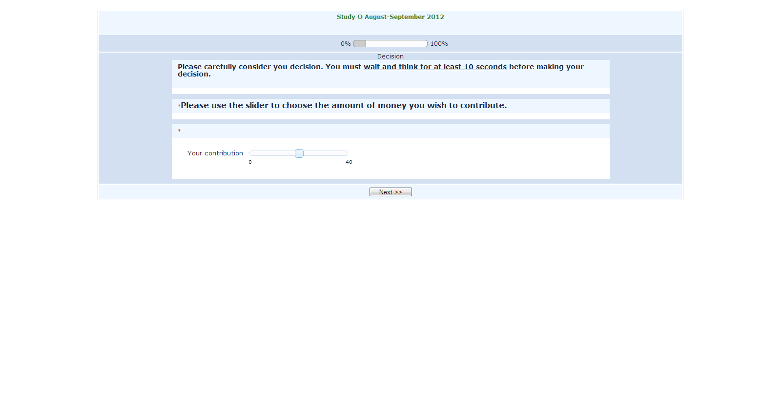

*Screen 3*

